CMPE343 - Database Management Systems and Programming I
Term Project: Ercan Airport Management Information System
Group Members:
- Yusuf Demir - 22315170
- Malik Emre Gümüş - 22207534
- Ganime İpek Bolat - 22210254
- Berra Somuncu - 22303056
1. INTRODUCTION & ASSUMPTIONS In this project, we created a database system for Ercan Airport. The assignment asked for at least 8 tables, but since we wanted to build something closer to a real-life scenario (and get full points!), we decided to add "Airline" and "Flight" tables too. So, our final design has 11 tables in total.
Assumptions We Made: While designing the ER diagram, we made a few assumptions to keep the logic simple and working:
- Employee Roles: Traffic controllers and technicians are just specific types of employees. Because of this, they share the same SSN with the main Employee table. We showed this as an "is-a" relationship in our ERD.
- Technician Skills: One technician can know about multiple airplane models, and one model can be fixed by many technicians. To solve this many-to-many relationship, we added a Technician_Expertise table.
- Hangar Tracking: Planes don't stay in the hangar forever. We record their entrance (date_in) and exit (date_out). If date_out is NULL, it means the plane is still inside.
- Testing Process: A test requires an airplane, a technician, and a specific test type. We keep track of this in the Testing_Event table, along with the date, duration, and the score the plane got.
2. RELATIONAL DATA MODEL We tried to follow 3rd Normal Form (3NF) rules to avoid repeating data.
- Primary Keys (PK): Each table has a unique identifier, like ssn for employees or plane_no for airplanes.
- Foreign Keys (FK): We linked our tables using foreign keys. For example, a technician's SSN in the Testing_Event table must match a real technician in our system. We also added ON DELETE CASCADE rules. This way, if an employee is removed from the system, their related records disappear automatically without giving us database errors.

3. ENTITY-RELATIONSHIP DIAGRAM (ERD)

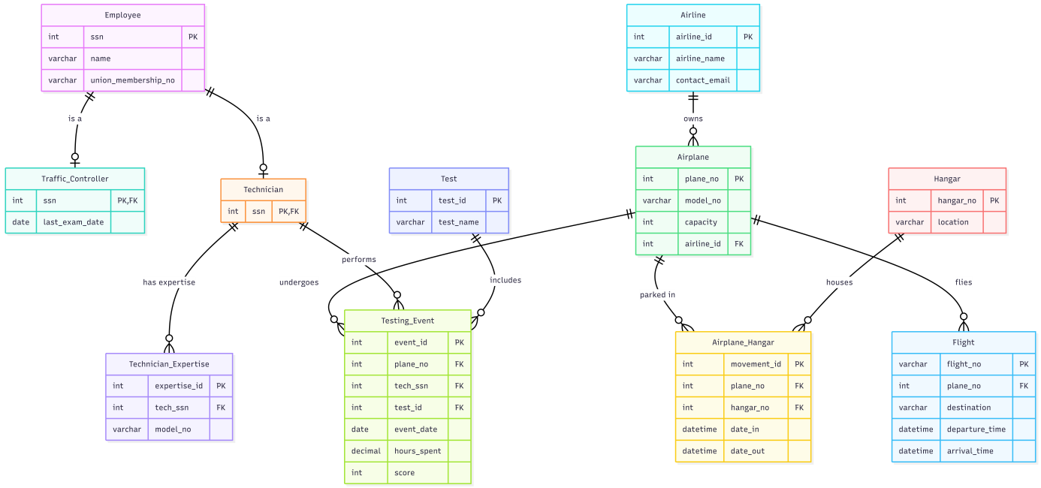

4. SQL CODES & STATISTICAL QUERIES We wrote the DDL codes to create tables, DML codes to insert some dummy data, and 15 statistical queries for management reporting. You can find all these SQL files and our ER diagram in our GitHub repository.
GitHub Repository Link: https://github.com/exzoncrp/Ercan-Airport-Management-System
Queries Examples:
Queries 7:
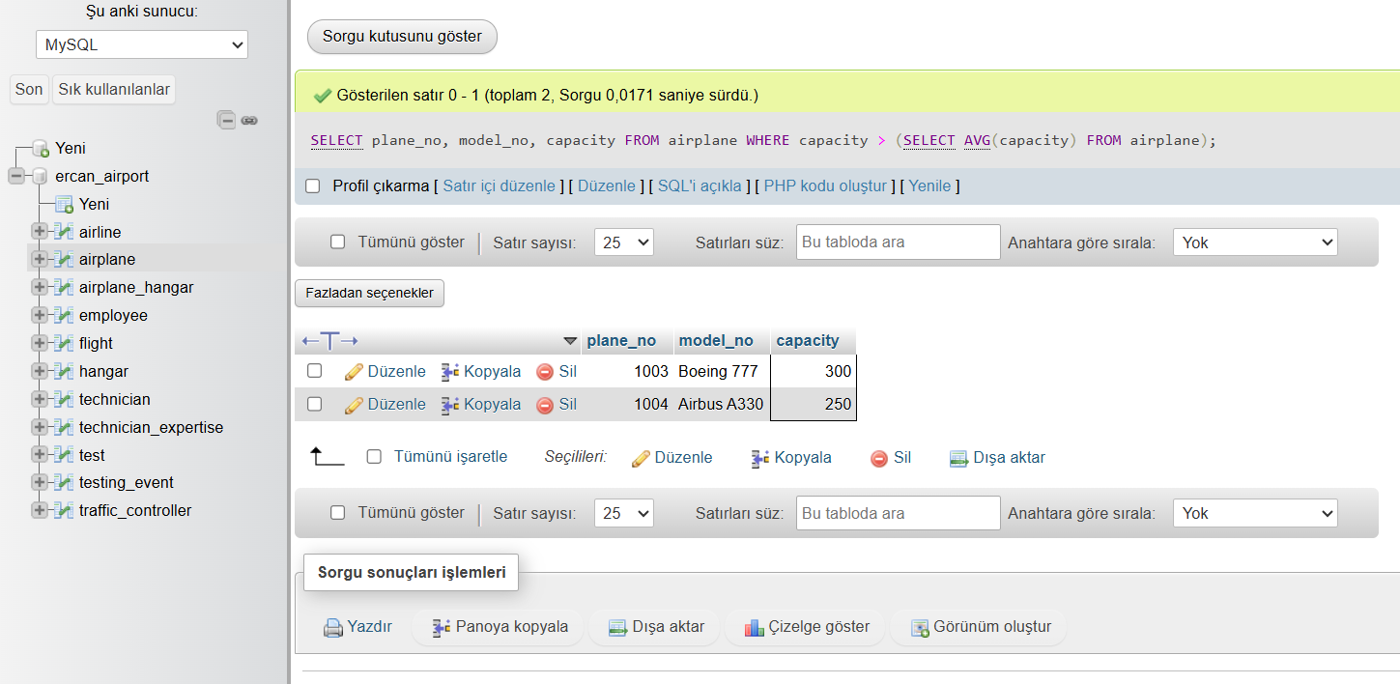

Queries 3:
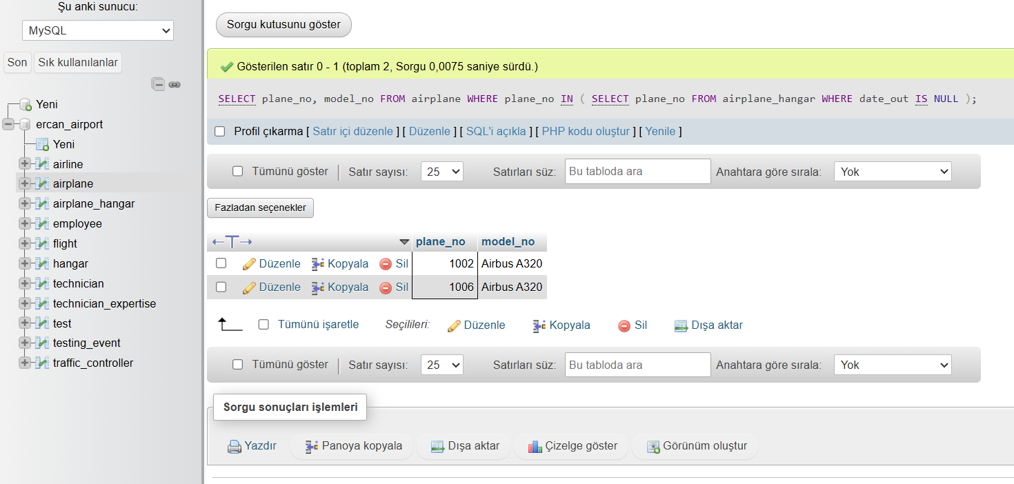
Queries 12:
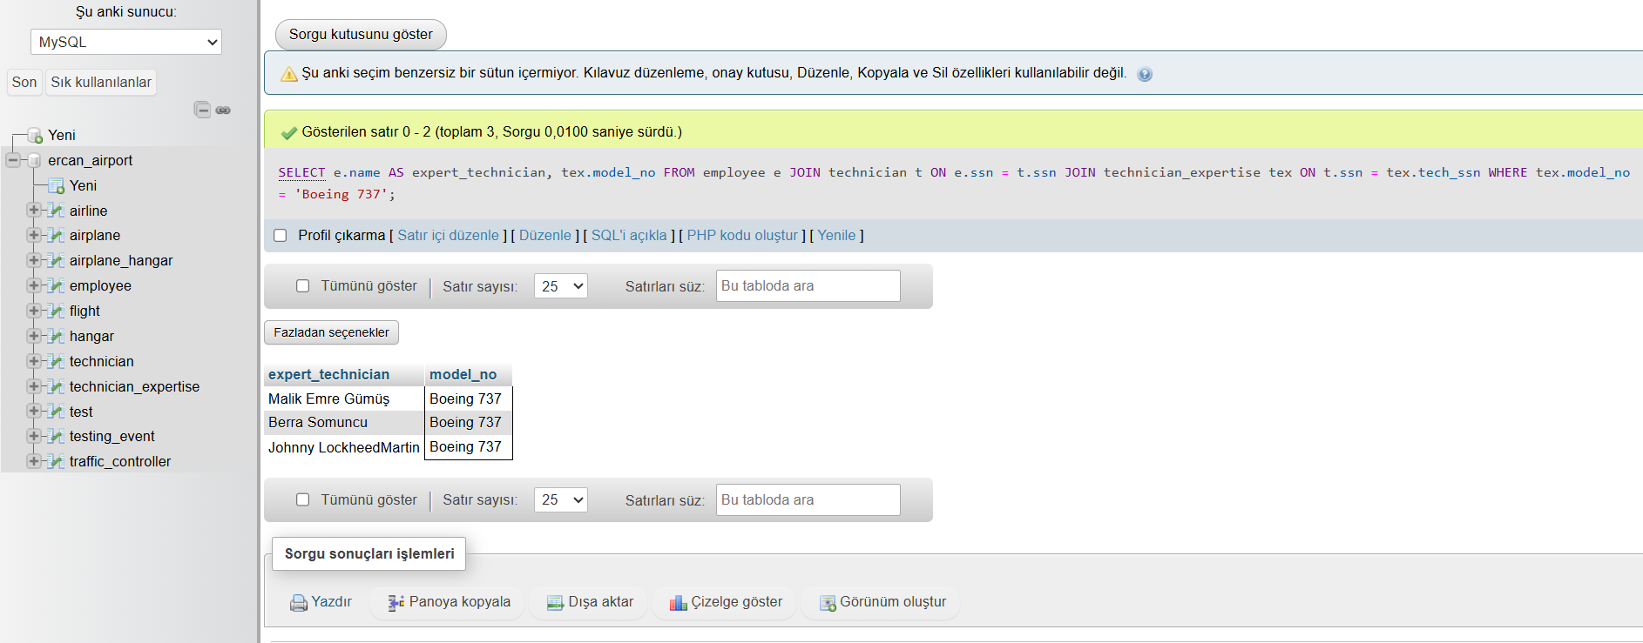
Queries 15:
